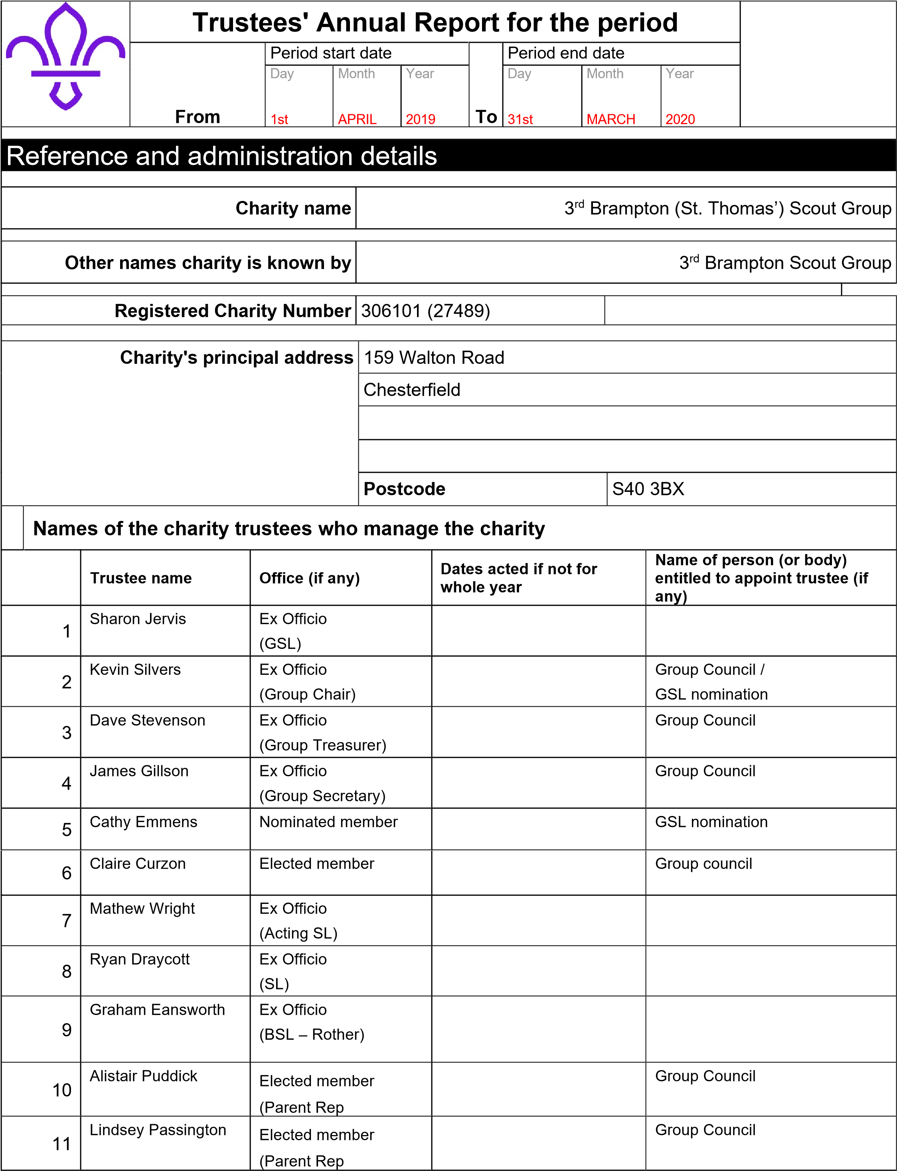

Structure, governance and management

Description of the charity’s trusts
The Group's governing documents are those of The Scout Association. They consist of a Royal Charter, which in turn gives authority to the Bye Laws of the Association and The Policy, Organisation and Rules of The Scout Association.

The Group is a trust established under its rules which are common to all Scouts
The Trustees are appointed in accordance with the Policy, Organisation and Rules of The Scout Association
Type of governing document

How the charity is constituted

Trustee selection methods

Additional governance issues (Optional information)

The Group is managed by the Group Executive Committee, the
members of which are the ‘Charity Trustees’ of the Scout Group
which is an educational charity. As charity trustees they are
responsible for complying with legislation applicable to charities.
This includes the registration, keeping proper accounts and making returns to the Charity Commission as appropriate.

The Committee consists of 3 independent representatives,
Chair, Treasurer and Secretary together with the Group Scout Leaders, individual section leaders and parent’s representation and meet every 2 months.

This Group Executive Committee exists to support the Group Scout Leader in meeting the responsibilities of the appointments and is responsible for:

*The maintenance of Group property;
*Assisting in the recruitment of leaders and other adult support;
*Appointing any sub committees that may be required;
*Appointing Group Administrators and Advisors other than those who are elected.
*The raising of funds and the administration of Group finance;
*The insurance of persons, property and equipment;
*Group public occasions;

Risk and Internal Control

The Group Executive Committee has identified the major risks to which they believe the Group is exposed, these have been reviewed and systems have been established to mitigate against them. The main areas of concern that have been identified are:

Reduction or loss of members. The Group provides activities for
all young people aged 6 to 14. If there was a reduction in membership in a particular section or the group as whole then there would have to be a contraction, consolidation or closure of a section. In the worst-case scenario, the complete closure of the Group.

Damage to the building, property and equipment. The Group Cont. would request the use of buildings, property and equipment from neighboring organisations such as the church, community centre and other Scout Groups. Similar reciprocal arrangements exist with these organisations. The Group has sufficient buildings and contents insurance in place to mitigate against permanent loss.

Injury to leaders, helpers, supporters and members. The Group through the capitation fees contributes to the Scout Associations national accident insurance policy. Risk Assessments are undertaken before all activities.

Reduced income from fund raising. The Group is primarily reliant upon income from subscriptions and fundraising. The group does hold a reserve to ensure the continuity of activities should there be a major reduction in income. The Committee could raise the value of subscriptions to increase the income to the group on an ongoing basis, either temporarily or permanently.

Reduction or loss of leaders. The group is totally reliant upon volunteers to run and administer the activities of the group. If there was a reduction in the number of leaders to an unacceptable level in a particular section or the group as a whole then there would have to be a contraction, consolidation or closure of a section. In the worst-case scenario, the complete closure of the Group.

Objectives and activities

The objectives of the Group are as a unit of The Scout Association.

The Aim of The Scout Association is to promote the development of young people in achieving their full physical, intellectual, social and spiritual potentials. We encourage individuals, to be responsible citizens in their communities and members of their local/national and international communities. The method of achieving the Aim of the Association is by providing an enjoyable and attractive scheme of progressive training, based on the Scout Promise and Law and guided by adult leadership.

Summary of the objects of the charity set out in its
governing document
Summary of the main
activities in relation to these objects
Additional details of objectives and activities (Optional information)

Achievements and performance

The main achievements of the 3rd Brampton (St. Thomas’) Scout Group are summarised in the Scouters reports contained further in this document.

- Group Scout Leaders report
- Beaver Scout Leaders report
- Cub Scout Leaders report
- Scout Leaders report
Summary of the main achievements of the charity during the year

Financial review

Reserves Policy

The Group's policy on reserves is to hold sufficient resources to continue the charitable activities of the group should income and fundraising activities fall short. The Group Executive Committee considers that the Group should hold a sum equivalent to 12 months running costs, circa £18,000.

The Group held reserves of approximately £10,000 against this at year-end. This is above the level required for operating expenses. However, this can be explained by the Groups historic desire to construct its own meeting place and headquarters. Previous attempts to fundraise sufficient funds in order to construct the headquarters have failed and the capital, which was raised, were deposited and explain the high reserves held in the Group
Account/s. The ‘Group Headquarters Development Plan’ remains on-going and the Group Executive would also consider part funding a project which could mutually benefit the interested parties with regular accommodation and storage space at affordable overheads.

The Group Executive also considers that a healthy reserve is required to satisfy the Group’s policy on subsiding subscription, uniform and activity costs for the larger than average percentage of families which are eligible for ‘free school meals’ within our catchments area/s. (Free school meal eligibility is a nationally recognised measure for social deprivation).

A healthy reserve would also migrate risks from contingencies that may arise over the course of the year.

Brief statement of the charity’s policy on reserves
***Not Applicable***
Details of any funds materially in deficit
Further financial review details (Optional information)
Investment Policy
The Group's Income and Expenditure is very small and as a consequence does not have sufficient funds to invest in longer term investments such as stocks and shares. The Group has therefore, adopted a low risk strategy to the investment of its funds. All funds are held in cash using only mainstream banks or building societies or The Scout Association's Short-Term Investment Service.
The Group Executive regularly monitors the levels of bank balances and the interest rates received to ensure the group obtains maximum value and income from its banking arrangements. Occasionally this may involve using an account that requires a period of notice before funds may be withdrawn, before doing so the Group Executive considers the cash flow requirements.
Other optional information

Declaration

The trustees declare that they have approved the trustees’ report above.
Signed on behalf of the charity’s trustees
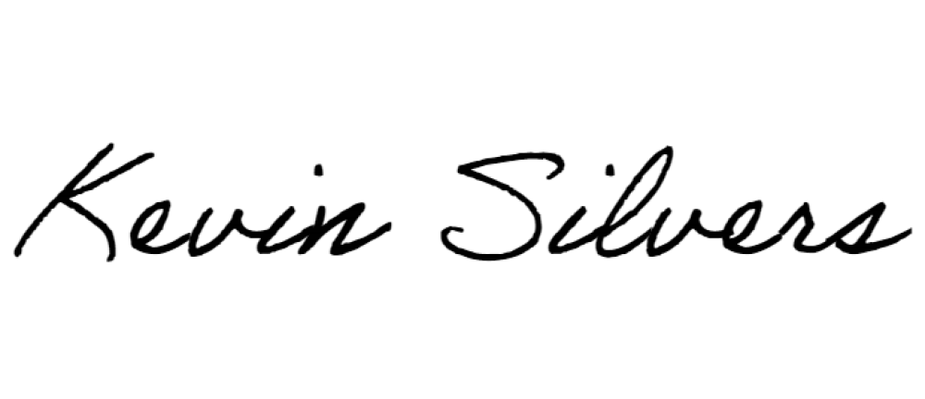
Kevin Silvers
Chair
Signature(s)
Full name(s)
Position (e.g. secretary, chair, etc)
01/07/2020
Date

